Events Management: Principles & Practice, 4th Edition

Instructor’s Manual

Written by: Dr Razaq Raj and Dr Tahir Rashid
Chapter 15
Event Production, Design and Lighting

Chapter Overview

The chapter will discuss event production management and event design for the live events. It will offer a clear understanding of event lighting design, address the legal requirements and discuss how to enhance the experience of spectators who attend live events and festivals. The chapter will provide a practical guide for events staff to understand how lighting can be used at live events to enhance the atmosphere for spectators. This chapter will outline the importance of health and safety standards in lighting design at live events and the use of 3D technology equipment.
Exercises and activities

Tips for Tutor

- Ask each student to read following sections from the chapter 15, before coming to class.

- Event Production Management
- Event Production Team and Safety Advisory Group (SAG)
- Venue Design for Live Events
- Erection of Temporary Demountable Structures
- Lighting and Sound System

Tips for Tutor

It is best to begin the class by discussing the key elements of event lighting designs and stage production. Discuss with students’ a practical guide of lighting design use of visual production technology at live events and atmosphere that creates for spectators?

- Internet Resources
These are internet and YouTube clips, we recommend you ask students to visit internet sites and YouTube clips and asking them to watch and read the material for classroom discussion.
Internet resources

- https://www.youtube.com/watch?v=mb7xRcEH0Ts&t=19s
Lighting Terms & Techniques for Event Planners - WTF is a Digital Gobo?
Technology in lighting and video is ever changing, and it’s crucial for #EventProfs to stay ahead of the trends to keep their clients (and their companies) current. Whether you’ve been planning and designing events for 2 or 20 years there is always something new to market that you can add to your toolbox. Knowing the proper terms and how to best use the latest options in video mapping and lighting techniques will set you apart from the competition.

- https://www.youtube.com/watch?v=NQ_BX6tFfxM&t=2s
Back to Back New Year's Festivals! Lighting & Event Production Behind The Scenes
In this video, outline the production crew travelling around the USA to three festivals: Lights All Night in Dallas, Snow Globe in South Lake Tahoe, and finally Decadence in Denver.

- https://www.youtube.com/watch?v=Hyvf23QBFhY&t=3s
The Stage is Built! Let’s Do a Show - MIA Episode 3
On-site finishing the stage build for MIA Festival in Shanghai. We face some interesting problems as our production schedule gets impacted by forces out of our control. Join me as we troubleshoot issues with fixtures, work with guest LDs, and operate the show.

- https://www.youtube.com/watch?v=pht8gmILZPs&t=6s
Stage Build - March Madness Music Festival 2018
Production company building an outdoor stage for Madness Music Festival event and organising entertainment and managing the sound and lighting equipment of the event.

Tips for Tutor

  - Divide students into groups of four to five and instruct them to:

- Read Case Study 15.1: Burj Al Arab, Dubai
- Ask students to discuss the reasons for marquees that are capable of withstanding expected wind forces and bad weather conditions. Analyse why contractors that will be selected have necessary experience in marquees design and development?

Case Study 15.1: Burj Al Arab, Dubai

Located in Dubai “The City of gold” is the Burj Al Arab. Distinctive for its sail-shaped design, this venue towers over the ever growing Dubai coastline. Being named as the only 7-star hotel in the world, it oozes luxury and extravagance. The entrance is breath-taking greeted by striking gold pillars and dazzling fountains. Its design is matched by world class service, and attention to detail in everything. The venue boasts five swimming pools (three outdoor, two indoor), a private beach, spa and nine world class restaurants, all overlooking the stunning Dubai coastline.

This magnificent building offers nine deluxe indoor and outdoor event spaces. The showpiece being the Burj Al Arab Terrace, the newly opened terrace provides guests with incredible restaurants, pool, beach and cabana space, accommodating up to 800. Another of the spectacular spaces is the Al Falak Ballroom, designed over two tiers in the style of an 18th century Viennese Opera House. The ballroom space ranges from 50 guests to 250 depending on the type of event. The Burj Al Arab is the peak of opulence and a venue for the ultimate of events.
Source: Adopted from https://www.penguins.co.uk/blog/creative-event-venues

  - Divide students into groups of four to five and instruct them to:
• Read Case Study Case Study 15.4: Leeds Direct Arena Venue Design
- Ask students to discuss and evaluate the importance of design and production processes for the event team?
- Ask students to outline the event logistics for a music festival outline?

Case Study 15.4: Leeds Direct Arena Venue Design

The project of Building Leeds First Direct Arena has been an extended request of the citizens of Leeds which therefore was programmed as one of the twelve highest urgencies for Leeds City Council (Guardian Leeds, 2010). Moreover, Leeds Arena is designed to have a positive impact overall to the city and to ensure the usage of the city centre especially, by the visitors or tourists and residents.

The Leeds First Direct Arena, it is multi-purpose venue developed by the Leeds City Council to attract various different type of events and conferences to Leeds. The arena was designed as a fan-shaped arena in the United Kingdom with a 13,500 capacity. This was landmark venue that has been forefront of innovation in terms of delivery live events to people of Leeds. The Leeds’s £60m Arena was officially opened in 4th of September 2013 with the performance of Sir Elton John, were 12.000 people attended the concert.

Leeds First Direct Arena is the major entertainment venue located in the vibrant city centre of Leeds, hosting live music, comedy, entertainment shows and sporting events. Leeds First Direct Arena not only offers musical concerts but also offers an accommodation for various events such as: Music performances in numerous outlines, Family shows such as comedy or ice dance shows, Sport events: including Election accounting venue for Leeds City Council, Wrestling and Basketball, Graduation Ceremony for Leeds Beckett University and BBC Sport Personality of the Year etc.

Leeds First Direct Arena is scheduling to show more than 140 events per year. Arena has a unique design of honeycomb with lights. These lights changes depending on the mood of the arena. The city council owns the arena however the management group SMG Europe is the one who runs the arena.

Technical Event Production
The Leeds First Direct Arena offer cutting edge design that has become pride of Leeds. Technical design layout creates significant visitor experience and Arena also offers rows of seats sweep outwards from the stage, illumination it an easy-to-see pivotal theme. The exceptional layout also positions spectators much closer to the stage than typical bowl seating, offering astonishingly vantage points to virtually all audience members. One of the main features of the Arena is that during the night, Arena is illuminated so that it can be seen for miles around city. In addition, Arena offers ground-breaking colour changing LED lighting system to attract visitor’s attention and also covered within the façade can be controlled to accomplish theatrical result, along with reflecting the nature of the events or show being organised at the Arena. The major technical imagination that been designed was lighting effect around the arena to enrichment and re-generating the city.

The Arena is designed to enhance visitor / attendees experience with all seats facing the actual stage. Also providing close vision for audience to enjoy the atmosphere by reduced viewing distance with high quality facilities been developed to provide exceptional style venue for event attendees. The venue can accommodate up to 13,500 visitors or 2,000 square meters exhibition space. The Arena also offer following production facilities for the event organisers:

- Lighting designers,
- Projection masters and audio aces
- Blended with cutting edge kit and keep your audience captivated and engaged.
- 3D visualisation
- Fly-throughs and CAD

The Leeds First Direct Arena also offer creative support in-house set and staging team create something that is bespoke and bang on brief to clients need as shown in figure 15.6 below.

Figure 15.6 Creative Layout of Leeds Arena

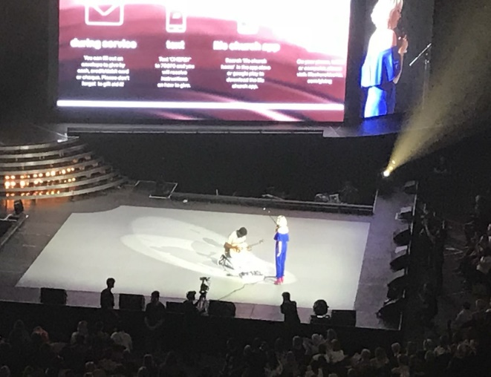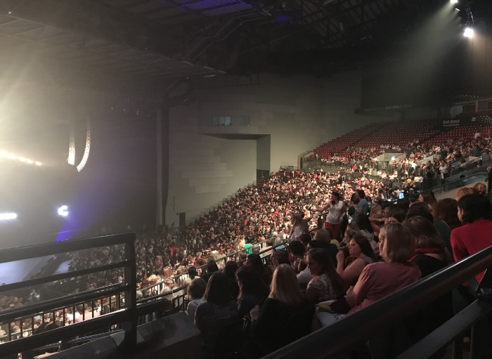
Photos: Ruth Dawson, Leeds Beckett University

Source: https://www.firstdirectarena.com/conference-events/technical-event-production/

- Discussions questions

Question 1
Discuss the reasons for electrical installations should be installed, tested and maintained in accordance with the provisions of the IEE Regulations for Electrical Installations. Why are the following 3 test certificates important under the HSE guidance HSG107 Maintaining portable and transportable electrical equipment, regular PAT test, visual inspection on each set up and RCD in every circuit?
Question 2
Critically discuss why organisers should check and monitor the contractors and design of the temporary demountable structures to make sure it meets health and safety standards outlined by The Management of Health and Safety at Work Regulations 1999 and they are in good condition? Discuss why contractors need to provide an advance written risk assessment?

Question 3
What are the benefits of Safety Advisory Group (SAG) and analyse purpose of having SAGs representatives from all emergency services, key stakeholders and event organiser?
Question 4
Identify and evaluate a practical guide for events staff to understand the lighting design use of visual production technology at live events and safety standards and in good condition?

